

Lab Project: Project Proposal
Crossing Gate System

Instructor: Rameez Ashraf

SMRTTECH 3CC3
Cloud Computing and Internet of Things
B. Tech - SMRTTECH

Submitted by: Nicolas Jao - 400450151
Partner (s): Jacob Kwan - 400453713
Lab Section: L04
Abstract
There are many intersections between railroads and cars. To ensure the safety of the passengers in the cars, automated gate systems must be implemented to tell cars to stop before the intersection when a train is coming. There should also be a sensor to detect if a car or person or any other obstruction is mistakenly in the intersection even when the gates are down. This project aims to achieve this task by building a prototype of this system using a microcontroller, ultrasonic sensor, infrared sensors, and servo motors. This project intends to close the gates to an intersection when sensors detect a train is coming, turn on an obstruction detection system once it knows a train is coming, turn off the obstruction detection system once the train arrives, then open the gates to the intersection when the train has left. If the obstruction detection system detects an obstruction, the system intends to send this information to the cloud so that it will alert the train to slow down or stop if necessary.

Description
In countries all over the world, there are intersections where railroads for freight cargo trains or public transportation trains pass through roads for civilian automobiles. A safety system must be implemented to ensure the safety of the civilians whenever a train passes, and because there could be many of these intersections for one railroad, automating this safety system is paramount for efficient safety. Our automated crossing gate system employs sensors and actuators to achieve the task of closing and opening gates on both sides of the railroad to block civilian cars from crossing the railroad when a train is passing by. This is done by 3 pairs of IR transmitters and receivers and 2 servo motors. The first IR sensor pair detects a train is coming from kilometres away, activating the 2 servo motors to close 2 gates on both sides of the railroad. The second IR sensor pair is past the railroad and detects when the train has fully passed the crossing, so that the gates can be reopened and the civilian cars can drive through. The third IR sensor pair is in conjunction with 1 ultrasonic sensor as a subsystem to detect if there are current obstructions on the crossing. The ultrasonic sensor has a threshold of a minimum distance, and if it detects less than that distance, it knows something is blocking it, and that there is a car or another obstruction in the crossing. If so, it will send this data to the cloud, and if the train is connected to the cloud, it will receive an alert so that it can slow down or stop completely. The third IR sensor pair’s purpose is to detect if the train is nearby enough to the intersection and if so, it will disable the ultrasonic sensor system so that it does not mistake the train as an obstruction.

List of Components
- 1 Arduino MEGA
- 1 ultrasonic sensor
- 3 pairs of IR transmitters + receivers
- 2 servo motors
- 4 red LEDs
- 4 resistors
- 1 passive buzzer
- Breadboards and wires
- PC with LabVIEW and Ubidots
- Props (toy car, toy train)
- Cardboard

Electrical Schematic
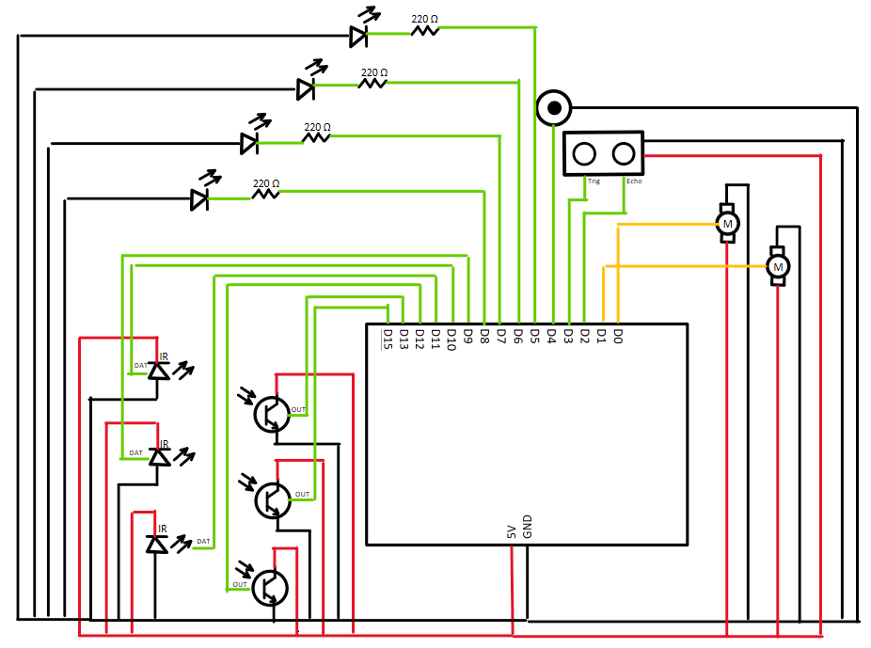

Gantt Chart Timeline

